Magic Bricks

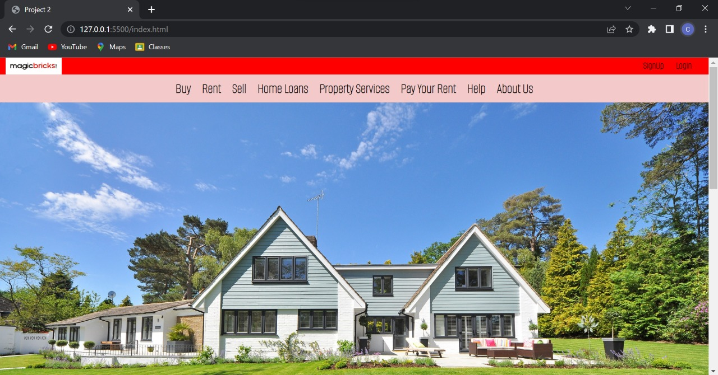

Chinmay Agrawal

Edureka Presents

**Magicbricks**, a division of Times Internet Limited, a wholly owned subsidiary of Bennett, Coleman & Co. Ltd (The Times Group) is a website that provides a common platform for property buyers & sellers to locate properties of interest in India, and source information about all property related issues.

Technologies Used :

* Html
* CSS
* JS
* Bootsrap

Goals :

* Login Page
* Sign Up Page
* Payment Gateway
* Premium Member Page

Website : https://www.magicbricks.com/